***Dt : 9/9/2022***

***Note:***

***=>we can perform insert(),delete() and reverse() operations on***

***StringBuffer object.***

***Ex : DemoBuffer2.java***

***package maccess;***

***public class DemoBuffer2 {***

***public static void main(String[] args) {***

***StringBuffer sb = new StringBuffer();***

***sb.append("java");***

***System.out.println("sb:"+sb.toString());***

***sb.append("program");***

***System.out.println("sb:"+sb.toString());***

***sb.insert(4," language ");***

***System.out.println("sb:"+sb.toString());***

***sb.delete(4,8);***

***System.out.println("sb:"+sb.toString());***

***sb.reverse();***

***System.out.println("sb:"+sb.toString());***

***sb.delete(4,7);***

***System.out.println("sb:"+sb.toString());***

***}***

***}***

***o/p:***

***sb:java***

***sb:javaprogram***

***sb:java language program***

***sb:javaguage program***

***sb:margorp egaugavaj***

***sb:marg egaugavaj***

***==========================================================***

***Assignment:***

***wap to read a String and check the String is palindrome string or***

***not using Built-in method reverse()?***

***============================================================***

***case-2 : Object creation using 'java.lang.StringBuffer(int)'***

***syntax:***

***StringBuffer sb = new StringBuffer(4);***

***=>In this syntax the StringBuffer object is created with the***

***default capacity equal to the number passed as parameter while***

***object creation process.***

***=>when the length crosses the capacity then the capacity is***

***increased automatically by doubling the capacity and adding 2.***

***Ex : DemoBuffer3.java***

***package maccess;***

***public class DemoBuffer3 {***

***public static void main(String[] args) {***

***StringBuffer sb = new StringBuffer(4);***

***System.out.println("default capacity:"+sb.capacity());***

***System.out.println("length:"+sb.length());***

***sb.append("java");***

***System.out.println("sb:"+sb.toString());***

***System.out.println("capacity:"+sb.capacity());***

***System.out.println("length:"+sb.length());***

***sb.append("NITHYD");***

***System.out.println("sb:"+sb.toString());***

***System.out.println("capacity:"+sb.capacity());***

***System.out.println("length:"+sb.length());***

***sb.append("Javalangauge");***

***System.out.println("sb:"+sb.toString());***

***System.out.println("capacity:"+sb.capacity());***

***System.out.println("length:"+sb.length());***

***sb.append("KjavaNITHYDJavalangaugeK");***

***System.out.println("sb:"+sb.toString());***

***System.out.println("capacity:"+sb.capacity());***

***System.out.println("length:"+sb.length());***

***sb.append("K");***

***System.out.println("sb:"+sb.toString());***

***System.out.println("capacity:"+sb.capacity());***

***System.out.println("length:"+sb.length());***

***}***

***}***

***o/p:***

***default capacity:4***

***length:0***

***sb:java***

***capacity:4***

***length:4***

***sb:javaNITHYD***

***capacity:10***

***length:10***

***sb:javaNITHYDJavalangauge***

***capacity:22***

***length:22***

***sb:javaNITHYDJavalangaugeKjavaNITHYDJavalangaugeK***

***capacity:46***

***length:46***

***sb:javaNITHYDJavalangaugeKjavaNITHYDJavalangaugeKK***

***capacity:94***

***length:47***

***==================================================***

***case-3 : Object creation using 'java.lang.StringBuffer(String)'***

***syntax:***

***StringBuffer sb = new StringBuffer("NITHYD");***

***=>In this syntax the StringBuffer object is created with the***

***default capacity equal to the sum of "16 + length of String passed***

***as parameter".***

***Ex : DemoBuffer4.java***

***package maccess;***

***public class DemoBuffer4 {***

***public static void main(String[] args) {***

***StringBuffer sb = new StringBuffer("NITHYD");***

***System.out.println("sb:"+sb.toString());***

***System.out.println("default capacity:"+sb.capacity());***

***System.out.println("length:"+sb.length());***

***sb.append("JavaProgrammingK");***

***System.out.println("sb:"+sb.toString());***

***System.out.println("capacity:"+sb.capacity());***

***System.out.println("length:"+sb.length());***

***sb.append("K");***

***System.out.println("sb:"+sb.toString());***

***System.out.println("capacity:"+sb.capacity());***

***System.out.println("length:"+sb.length());***

***}***

***}***

***o/p:***

***sb:NITHYD***

***default capacity:22***

***length:6***

***sb:NITHYDJavaProgrammingK***

***capacity:22***

***length:22***

***sb:NITHYDJavaProgrammingKK***

***capacity:46***

***length:23***

***==========================================================***

***case-4 : Object creation using 'java.lang.StringBuffer(CharSequence)'***

***syntax:***

***StringBuffer sb1 = new StringBuffer("TASK");***

***StringBuffer sb2 = new StringBuffer(sb1);***

***=>This syntax is used to interlink two StringBuffer objects,which***

***means one StringBuffer object is holding the reference of another***

***StringBuffer object.***

***Diagram:***

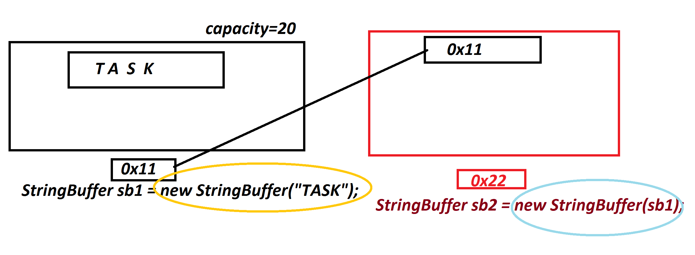

***Ex : DemoBuffer5.java***

***package maccess;***

***public class DemoBuffer5 {***

***public static void main(String[] args) {***

***StringBuffer sb1 = new StringBuffer("TASK");//Capacity-20***

***StringBuffer sb2 = new StringBuffer(sb1);//Capacity-20***

***System.out.println("sb2:"+sb2.toString());***

***System.out.println("default capacity:"+sb2.capacity());***

***System.out.println("length:"+sb2.length());***

***}***

***}***

***o/p:***

***sb2:TASK***

***default capacity:20***

***length:4***

***========================================================***

***Assignment:***

***wap to read a String and display the reverse of words from the***

***String?***

***i/p : java language program***

***o/p : avaj egaugnal margorp***

***=======================================================***